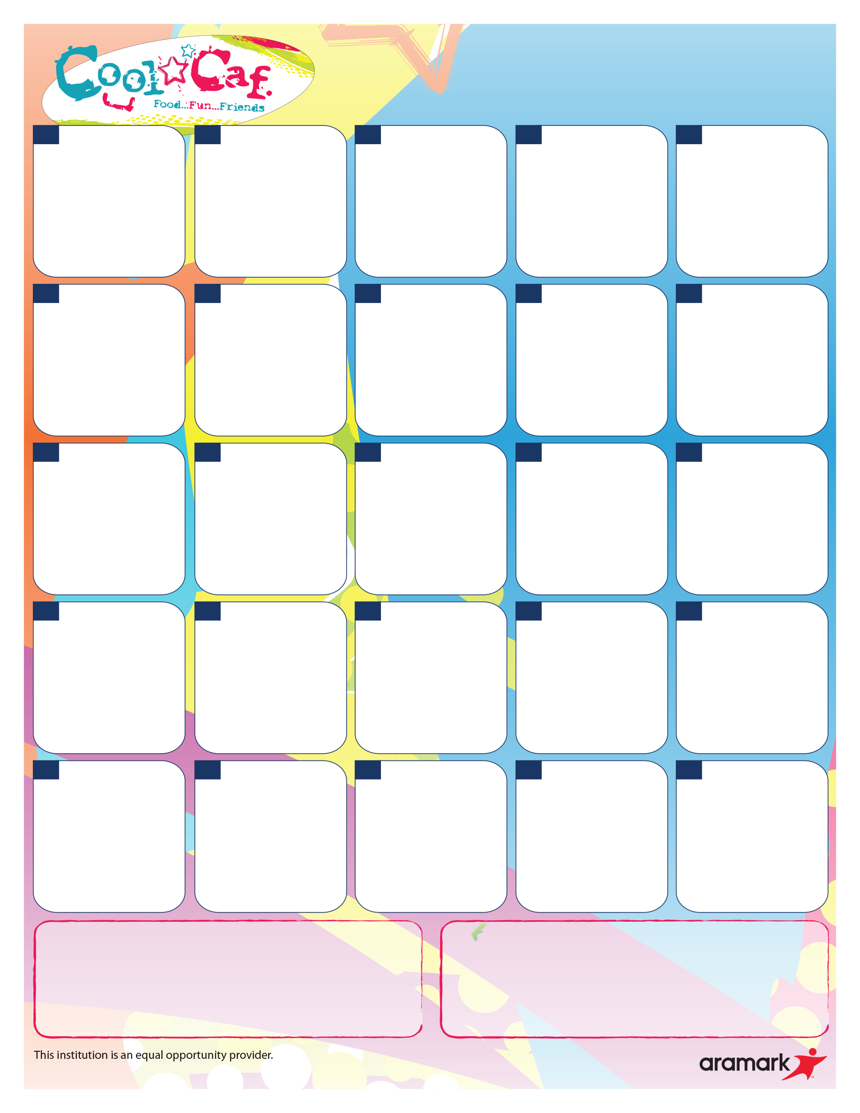**Grap**

**Chicken Patty Sandwich**

Ham & Cheese Sub(P)

Sun Butter & Jelly Sandwich(V)

Carrot Coins

Crisp Cucumbers

**Grilled Cheese Sandwich**

Tuna Salad Sub

Sun Butter & Jelly Sandwich**(V)**

**Green Beans**

**Sweet Baby Carrots**

**Cheese Pizza**

Chicken Ranch Salad

Sun Butter & Jelly Sandwich(V)

Mixed Veggies

Side Salad

**Early Release Day**

**Lunches available**

**In the Cafeteria**

**At Dismissal**

**Beef Cheeseburger**

**Beef Burger**

**Veggie Burger**

Ham & Cheese Sub(P)

Sun Butter & Jelly Sandwich(V)

Veggie Beans

Grape Shaped Tomatoes

21

**HAVE A**

**WODERFUL**

**SUMMER BREAK**

**😊**

**Beef Cheeseburger**

**Beef Burger**

**Veggie Burger**

Ham & Cheese Sub(P)

Sun Butter & Jelly Sandwich(V)

Veggie Beans

Grape Shaped Tomatoes

**Ball Park Turkey Frank**

Turkey & Cheese Sub

Sun Butter & Jelly Sandwich(V)

Carrot Coins

Grape Shaped Tomatoes

**NO SCHOOL**

**SUMMER BREAK**

**BEGINS**

**20**

**Breakfast for Lunch**

Turkey & Cheese Sub

Sun Butter & Jelly Sandwich(V)

Mixed Veggies

Grape Tomatoes

7

**Breakfast for Lunch**

Turkey & Cheese Sub

Sun Butter & Jelly Sandwich(V)

Mixed Veggies

Grape Tomatoes

**Cheese Pizza**

Chicken Ranch Salad

Sun Butter & Jelly Sandwich(V)

Broccoli Florets

Sweet Baby Carrots

**13**

**Chicken Nuggets**

**Dinner Roll**

Ham & Cheese Sub(P)

Sun Butter & Jelly Sandwich(V)

Carrot Coins

Crisp Cucumbers

**MENUS SUBJECT TO CHANGE WITHOUT NOTICE.**

**(P) Items contain pork (V) Vegetarian**

**OFFEERED DAILY: 1%** White & Skim Chocolate Milk, Assorted Fresh Fruits & Veggies. Sun Butter & Jelly Sandwich(V) Available on early release days: Sack Lunch/Bagel, Cream Cheese and Cheese Stick, Fruit & Vegetable and Milk (V) **Food Service Office at 617-846-5505 ext. 7210**

**9**

**22**

**150**

**8**

**16**

**23**

**27**

**14**

**30**

**6**

**5**

**2**

**Winthrop Public Schools**

Elementary School

**JUNE 2023**

**ALL MEALS ARE SERVED AT NO CHARGE TO STUDENTS.**

Breakfast Offerings: WHOLE GRAIN: Muffins/bagels/cereals/bars/breakfast sandwiches/donuts. Fruit & Milk

**26**

**28**

**29**

**19**

**12**

**1**